**Welcome to Amazon Lightsail for Research at Duke University!**

**IMPORTANT!**

* Your instance will shut down automatically without notice if left idle for >15 minutes. You should periodically save your work to minimize loss of information.
* Please be mindful of resource costs and stop your virtual computer when not in use.

**Getting Started**

**Step 1: Login to Lightsail for Research (LFR)**

You have been provided a unique onetime password to first get started with your account. Once you log in for the first time, you will be prompted to update your password. Your password must have at least 1 uppercase letter, 1 number and a special character.

**Note:** The account ID/alias is ‘du-mids’ rather than your individual account ID.

Console sign-in link: <https://du-mids.signin.aws.amazon.com/console>

Username: your Duke NetID

**Step 2: Open your LFR VM Dashboard**

LFR Console: <https://lfr.console.aws.amazon.com/ls/research/webapp/home/virtual-computers>

**Step 3: Launch your Virtual Computer**

Start Computer > Status: Running > Launch Ubuntu

**Note**: You will need to enable browser pop-ups for your Virtual Computer to launch.

Complete the Ubuntu setup to configure your keyboard and privacy settings.

**Step 4: Open Terminal**

From Home screen > Activities > Show Applications > Terminal

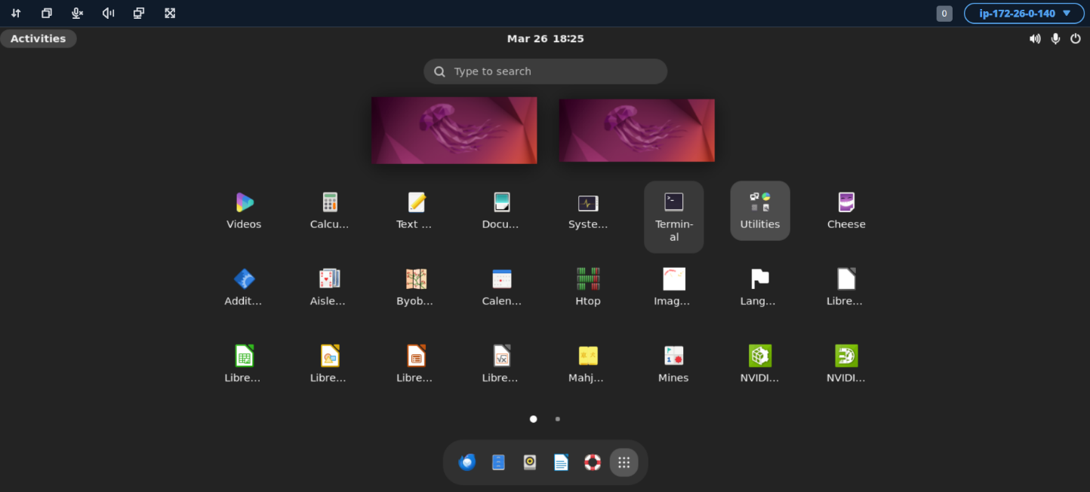

**Note:** You can also use the Terminal launch shortcut: CTRL + ALT + T

Run the following sanity checks in the terminal:

# Check GPU

$ nvidia-smi

# List directory contents

$ ls

**Note:** In Ubuntu, Copy/Paste commands are CTRL+SHIFT+C/V

You can expect outputs like the following:

**Step 4: Configuring your IDE**

The recommended IDE is VSCodium. Refer to the installation instructions for Ubuntu here: <https://vscodium.com/#install-on-debian-ubuntu-deb-package>

# Add GPG key

$ wget -qO - https://gitlab.com/paulcarroty/vscodium-deb-rpm-repo/raw/master/pub.gpg \

| gpg --dearmor \

| sudo dd of=/usr/share/keyrings/vscodium-archive-keyring.gpg

# Add repo

$ echo 'deb [ signed-by=/usr/share/keyrings/vscodium-archive-keyring.gpg ] https://download.vscodium.com/debs vscodium main' \

| sudo tee /etc/apt/sources.list.d/vscodium.list

# Install

$ sudo apt update && sudo apt install codium

Activities > Search: VSCodium > Pin to Dash

**You’re all setup and ready to use Amazon Lightsail for Research!**

**Password Management**

If you forget your password, please contact your administrator.

To change your password: Account > Security Credentials > Update Console Password

**SSH Access**

If you’d like to access your machine over SSH, you can follow these steps.

**Step 1: Request the key pair for your VM**

Ask your administrator for the private key pair and download to your local machine.

From your local terminal execute the following commands

$ cd/path/to/dkp_rsa

# Move key file

$ mv dkp_rsa ~/.ssh

# Set permissions

$ chmod 700 ~/.ssh

$ chmod 600 ~/.ssh/dkp_rsa

**Step 2: Retrieve your public IP address**

From your LFR instance dashboard > Start Computer > Copy Public IP address

NB: You may need to refresh the page once the VM is running to see the IP address.

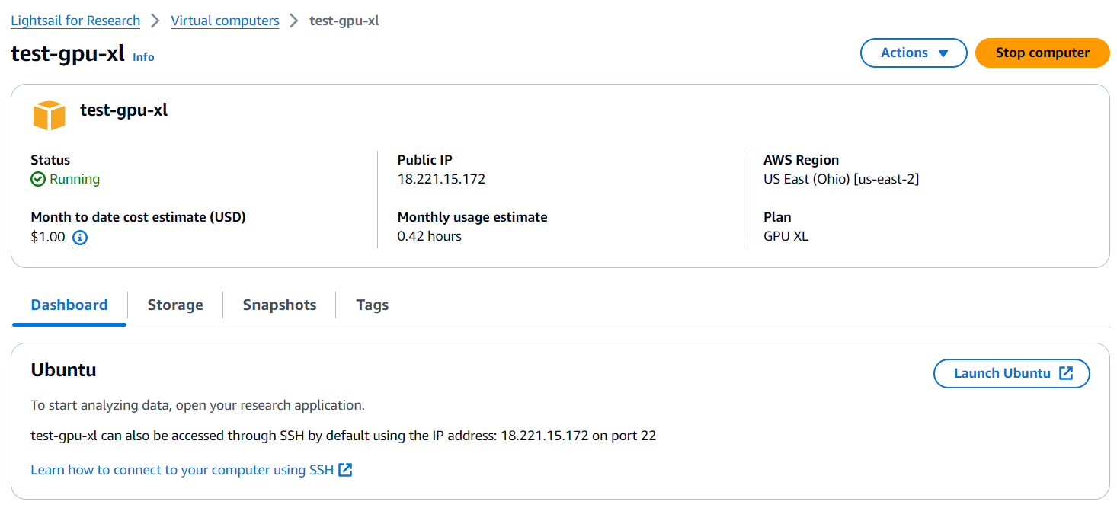

**Step 3: SSH into your VM**

From your local terminal

# Open SSH tunnel

$ ssh -i ~/.ssh/dkp_rsa ubuntu@<YOUR_PUBLIC_IP>

# Accept fingerprint and run sanity check

ubuntu@ip$ nvidia-smi

**IMPORTANT!** The user entry point for SSH (‘lightsail-user’) and the GUI (‘ubuntu’) are not the same. To preserve a seamless machine state if switching between SSH and GUI it is recommended you operate within the ‘lightsail-user’ directory.

ubuntu@ip$ cd ../lightsail-user

ubuntu@ip$ ls